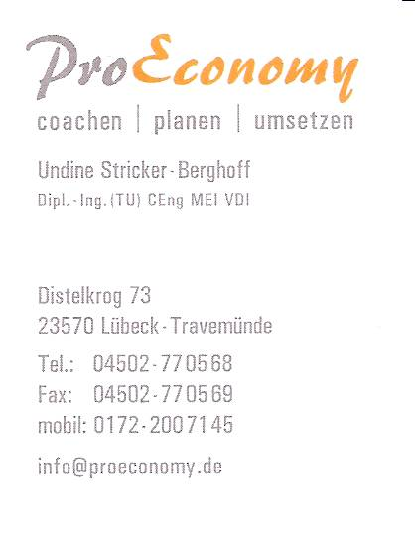
Questionnaire
“Women in the European Elevator Business”
I am writing an article for the U.S. magazine Elevator World in September 2016, hopefully with some fresh and unique data. Therefore, I would be grateful if you could personally answer a few questions until Tuesday 16 August by just typing in your answer and sending it back by mail to me. Please feel free to pass this questionnaire on to other women in the elevator business in Europe.

- About you
  - What profession did you train or study?
  - How long have you been you working at all? In the elevator business? In your company? In your job?
  - What type of company are you working in? e.g. producer of elevators/components, maintenance ...
  - What is your job in the company? e.g. management/owner, project manager, sales person …
  - Do you want to share some personal experience on your work in the elevator business?
What about a humorous or annoying story that happened to you?

- Some statistics
  - Do you have any figures on women in the elevator business in the EU, your home country and/or your own company?
  - Do you have any figures about women in engineering and/or management in the elevator business in the EU, your home country and/or in your own company?

- Political views
  - What do you see generally as the advantages and disadvantages of women in the elevator business?
  - What is done already to raise the percentage of women mainly in technical and management jobs in the EU, your home country and/or your own company?
  - What should be done to raise the percentage of women mainly in technical and management jobs in the EU, your home country and/or your own company?

- Contact data
If you would like to be interviewed by phone please give me your contact data including name, company, country, phone number and mail address.

I guarantee that I will use all answers only personally and anonymously for this article or similar publications or lectures. I will not pass them on to anybody else at any time. Your name, photo or company name will only be mentioned after a phone interview which will be individually legitimated before publication, too.
Thank you for your kind support of the project by contributing any information you may have!
Undine Stricker-Berghoff

